Design Document _games  
Daniel Pokladek, Willoughby Axtell, Lenneth Dayaon

# What is our game?

Genre: Roguelite, fast paced

The emotions we want to evoke  
We want to create a Fast-paced game so we will be looking to evoke emotions of:   
**Tension** – We want to create tension by making the game fast paced allowing players to be fully immersed and concentrated through sections of the game.

**Hard Fun** – providing players the opportunity of challenge, mastery and feelings of accomplishments.   
We will focus on the attention to a goal which is for the player defeat bosses and maybe in the future, to different parts of the map. The constraints and strategy of the way players will surpass through the maps with varied enemy’s with distinct properties. Mastering our mechanics as they play through random generated maps. To help them feel accomplishments to how far they get.

**Frustration** – perma death is a mechanic in our game so the player will have to start from the very beginning when they die.

**Fiero** – From the constant dying and failing, it will be more appreciated when players succeed to beat boss fights and proceed through the maps. This should evoke fierro through the player defeating an obstacle, especially one that is annoying.

**Relief** – Players can have relief after defeating boss fights and have times in the game where they are able to just have some time to pause or slow down without affecting their player’s life.

# Fantasy themed

(mystical magic themes, good vs. evil)   
  
Theme classified by a mixture of sub genres:   
**Comic Fantasy:** humorous in tone   
**Contemporary fantasy**: set in the real world by involving magic or other supernatural elements.   
**Heroic fantasy:** concerned with the tales of heroes in imaginary lands  
**Low fantasy:** characterized by a few or non-intrusive supernatural elements, often in contrast to high fantasy.

<https://en.wikipedia.org/wiki/Fantasy>

# Mechanics

**Core Game Loop:**

* Player Spawns in Level
* Player navigates map and collects items during day
* Player fights any enemies they come across
* After a designated amount of time the game switches to night
* During night more enemies spawn
* Player will have to prioritize survival over exploration during this phase
* During the night phase the player may fight the boss if this wish too
* If they decide not to the day phase starts again
* If they fight the boss and win, they will receive an item as a reward
* The player will then proceed to the next level (Unless on the final level)
* If the player character dies, they will restart the game

**Progression:**

Each stage will be more challenging than the last resulting in a progression of difficulty between stages this would be done by adding more challenging enemy variants and more enemies, players would have to counteract these difficulty increases by either becoming more skilled at the game or collecting items that will make them more powerful and thus make the game easier. This could cause players to spend large amounts of time collecting items to make themselves more powerful, a second form of difficulty progression is employed to counteract this being that for every day that passes in game the day gets shorter resulting in less time to prepare during future stages.

The game will also naturally improve player skill through repetition, the enemies that the player encounters will feature very simple AI and thus will be predictable allowing the player to figure out how best to fight each individual enemy as the character class they have chosen. Repetition will allow the player to be more likely to beat the game the more times they play it, alternate characters will allow for further variety. Alternate characters could also add to the progression of the game by allowing the player to unlock new characters by achieving goals in the game.

# Art style

* 2D at a 45-degree angle

Example:

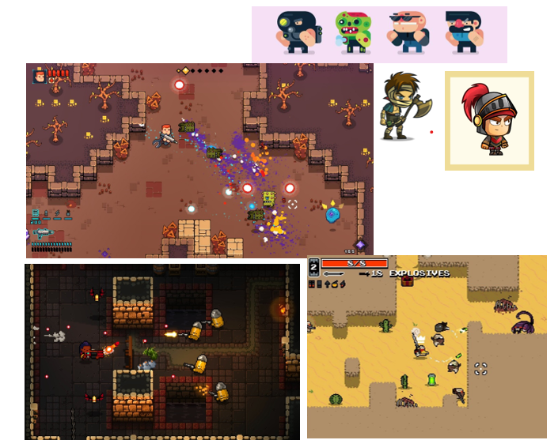

# WHAT ARE THE KEY DESIGN PROBLEMS YOU WILL FACE?

WHAT ARE THE KEY PROGRAMMING ISSUES YOU WILL HAVE WITH THIS GAME?